A Project Report on

Unleashing the Potential of Our Youth:

A Student Performance Analysis

**by**

**Team Leader :POTHUREDDY PRIYANKA(20AT1A05A8)**

**Student 1 :PAGIDALA JUNDA PRIYANKA (20AT1A05A7)**

**Student 2 :BAPURAM NIKITHA (20AT1A0598)**

**Student 3 :DVARAM VENKATASARANYA(20AT1A05I3)**

**Under the Guidance of**

**MRS.M.JAYA SUNITHA,M.Tech**

**Associate Professor**



## DEPARTMENT OF COMPUTER SCIENCE ENGINEERING

**G. PULLAIAH COLLEGE OF ENGINEERING AND TECHNOLOGY**

**(Autonomous)**

(Approved by AICTE | NAAC Accreditation with ‘A’ Grade | Accredited by NBA (ECE, CSE, EEE, CE) |

Permanently Affiliated to JNTUA)

# ABSTRACT

Student performance analysis is a crucial aspect of educational institutions as it allows educators and administrators to assess the academic progress and achievement of students. This analysis involves collecting and evaluating various data points related to students' academic performance, attendance, behavior, and other relevant factors. By analyzing this data, educators can identify patterns, strengths, weaknesses, and areas for improvement, thereby enabling personalized learning approaches to enhance student outcomes.

This abstract proposes a comprehensive analysis framework that incorporates both quantitative and qualitative methods to gain insights into student performance. The quantitative aspect involves using statistical measures to interpret exam scores, grades, attendance records, and other numerical data. Concurrently, qualitative analysis involves gathering feedback from teachers, students, and parents through surveys or interviews, shedding light on non-academic factors impacting student performance, such as motivation, learning styles, and social well-being.

Moreover, advanced technologies like machine learning and data analytics can be employed to uncover hidden patterns and correlations within vast datasets, providing more accurate predictions about student progress and potential risk factors. Such insights can an inclusive and positive learning environment.

Overall, student performance analysis plays a pivotal role in enhancing the educational experience, guiding curriculum improvements, and facilitating the success of all students, ultimately contributing to the overall growth and development of educational institutions.

# Contents

**Abstract** 2

**Contents** 3

**List of Figures and Tables** 4

**CHAPTER 1 INTRODUCTION 4**

**CHAPTER 2 LITERATURE REVIEW 5**

**CHAPTER 3 PROPOSED METHOD 6**

**CHAPTER 4 EXPERIMENTAL RESULTS 7-11**

**CHAPTER 5 APPLICATIONS/ADVANTAGES 12**

**CHAPTER 6 CONCLUSIONS & FUTURE SCOPE 13**

# LIST OF FIGURES AND TABLES

DataBase collected from IBM cognos about the **UNLEASHING THE POTENTIAL**

**OF OUR YOUTH: A STUDENT PERFORMANCE ANALYSIS**

# CHAPTER 1 INTRODUCTION

Education plays a pivotal role in shaping the future of individuals and societies. The quest for academic excellence has always been a fundamental aspect of educational institutions worldwide. In this pursuit, understanding and analyzing student performance have become crucial to identify areas of improvement and devise effective strategies to enhance learning outcomes. Student Performance Analysis is the systematic examination of various factors that influence academic achievement, aiming to gain insights into student progress, strengths, and challenges.

Traditionally, student performance was primarily measured by standardized tests and grades.. The availability of comprehensive datasets, comprising academic records, attendance data, socio-economic information, and other relevant variables, allows researchers and educators to adopt data-driven approaches to explore the multifaceted nature of academic performance. The potential impact of Student Performance Analysis extends beyond individual classrooms; it can inform policy decisions at the institutional, district, and even national levels.

This research area is particularly timely and relevant in the face of an ever-changing educational landscape. Factors like the rise of online learning, the impact of socio-economic disparities on access to education, and the need for personalized learning experiences demand innovative approaches to enhance student performance and close the achievement gap.

In this project of Student Performance Analysis, we aim to explore the rich and complex data available to us to gain insights that can drive positive change in the education system. By understanding the dynamics of student performance and analyzing the interplay of various factors

# CHAPTER 2 LITERATURE REVIEW

A literature review on student performance analysis would involve examining various studies, research papers, and articles related to the factors influencing student academic performance, the methodologies used for analysis, and the key findings from these studies.

Below is a general structure for a literature review on this topic:

1. Introduction:
   * Define the scope and purpose of the literature review.
   * Explain the significance of analyzing student performance and its implications for educational institutions.
2. Factors Influencing Student Performance:
   * Parental involvement and support
   * Teaching methods and quality of instruction
   * Student motivation and engagement
   * Learning environment and school infrastructure
   * Use of technology and educational resources
   * Extracurricular activities and their impact
   * Classroom size and student-teacher ratio
   * Educational policies and interventions

1. Methodologies for Student Performance Analysis:
   * Explore different research methodologies and data analysis techniques used to study student performance. These may include:
   * Qualitative methods (e.g., interviews, focus groups, case studies)
2. Review of Key Studies:
   * Summarize and analyze some of the seminal studies related to student performance analysis.
   * Highlight any controversies or conflicting results in the literature

1. Implications for Educational Practice:
   * Examine how the findings from the reviewed studies can be applied in educational settings to improve student performance.
   * Discuss potential interventions and strategies for addressing the factors that influence student academic outcomes.

1. Gaps in the Literature:
   * Identify any gaps or limitations in the existing research on student performance analysis.
   * Suggest areas for further investigation and potential research directions.

# CHAPTER 3 PROPOSED METHOD

There are several methods for student performance analysis, ranging from traditional quantitative approaches to more advanced data mining and machine learning techniques.

Here are some proposed methods commonly used in educational research and analysis:

1. **Standardized Tests and Assessments:**
   * Traditional standardized tests, such as SAT, ACT, or subject-specific assessments, provide a standardized and objective way to measure student performance and compare it across a broader population.
2. **Grades and GPA Analysis:**
   * Analyzing students' grades and Grade Point Average (GPA) can reveal trends in their academic progress and performance over time.

1. **Longitudinal Studies:**
   * Longitudinal studies involve following a cohort of students over an extended period, enabling researchers to track changes in performance and identify factors influencing academic outcomes.
2. **Learning Analytics:**
   * Learning analytics involves the use of educational data, such as Learning Management System (LMS) data, clickstream, and interaction logs, to identify patterns and insights into students' learning behaviors and outcomes.

1. **Social Network Analysis (SNA):**
   * SNA examines the relationships and interactions among students and teachers to identify how social dynamics influence academic performance.

1. **Case Studies and Qualitative Analysis:**
   * Conducting in-depth case studies and qualitative analysis allows researchers to gain a deeper understanding of specific factors affecting student performance in a particular context.

## CHAPTER 4 EXPERIMENTAL RESULTS

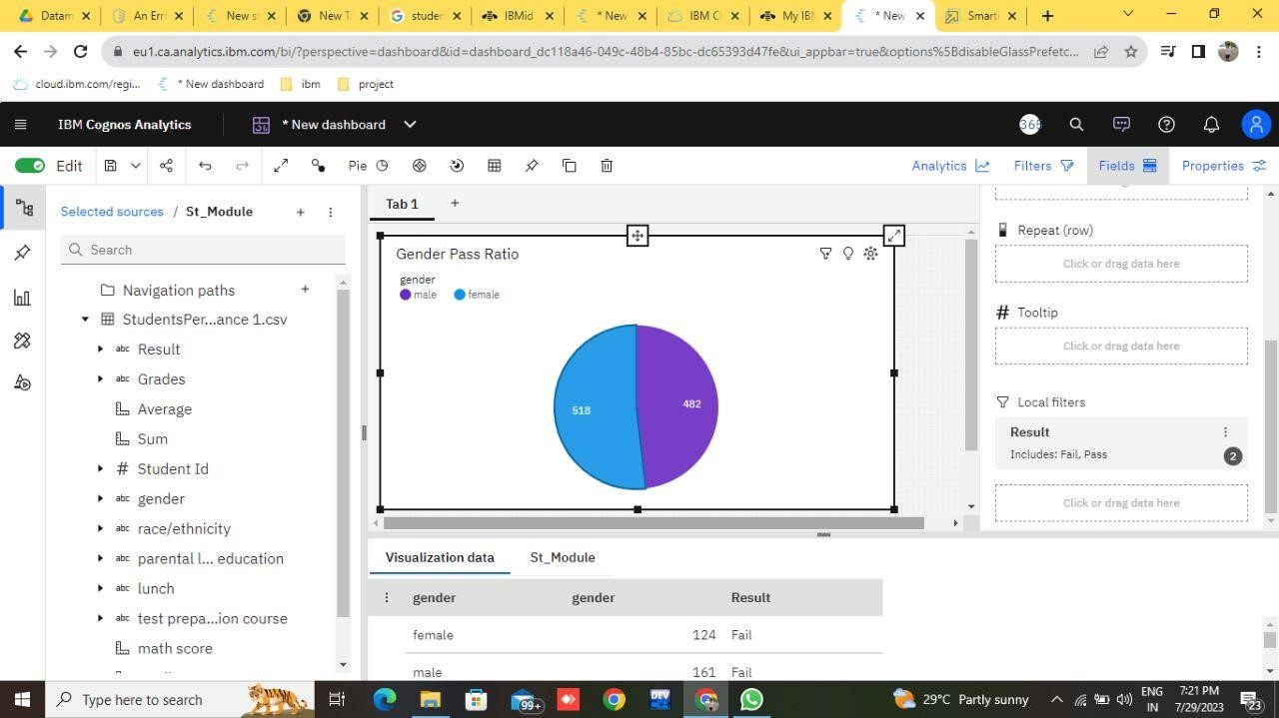

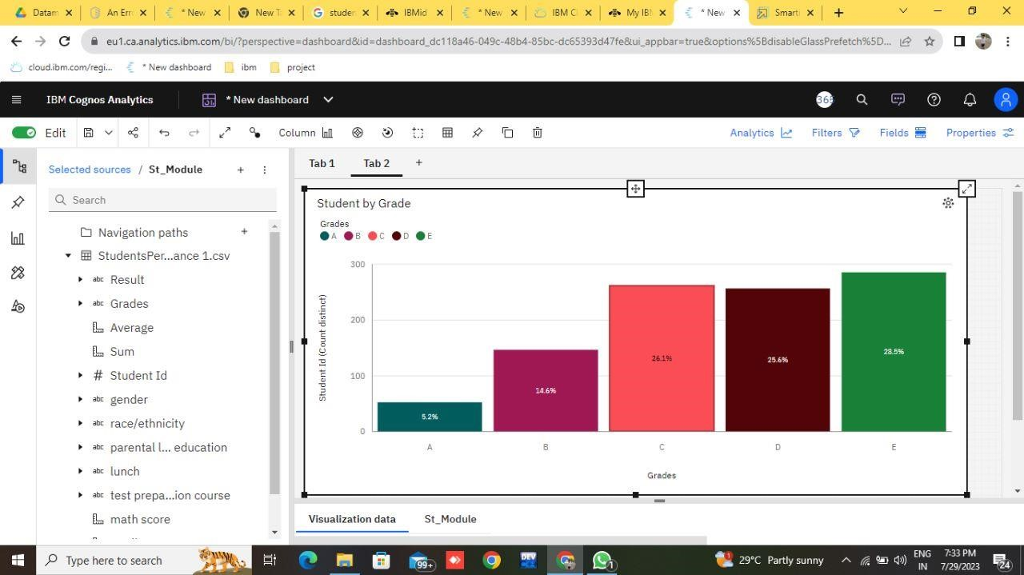

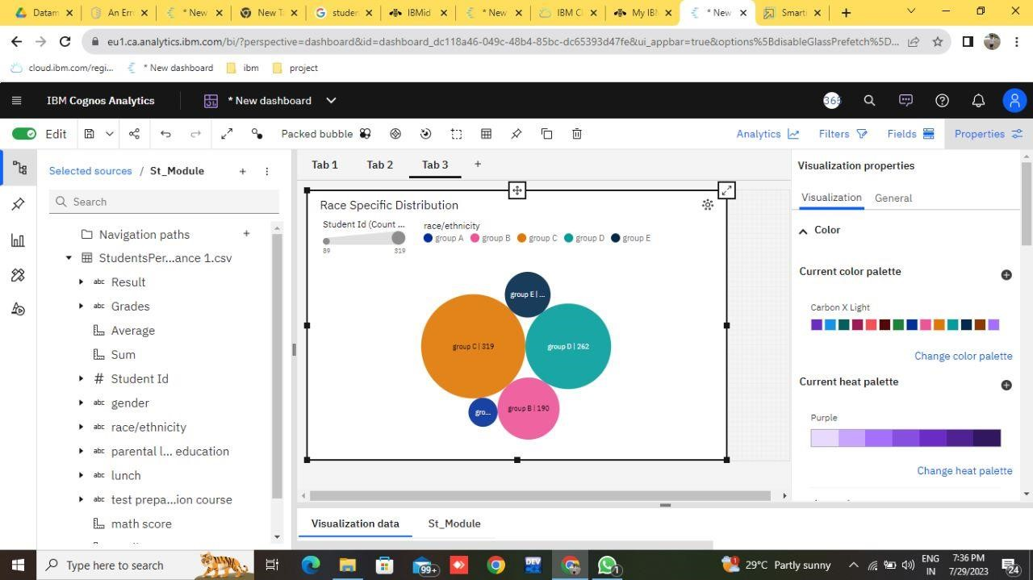

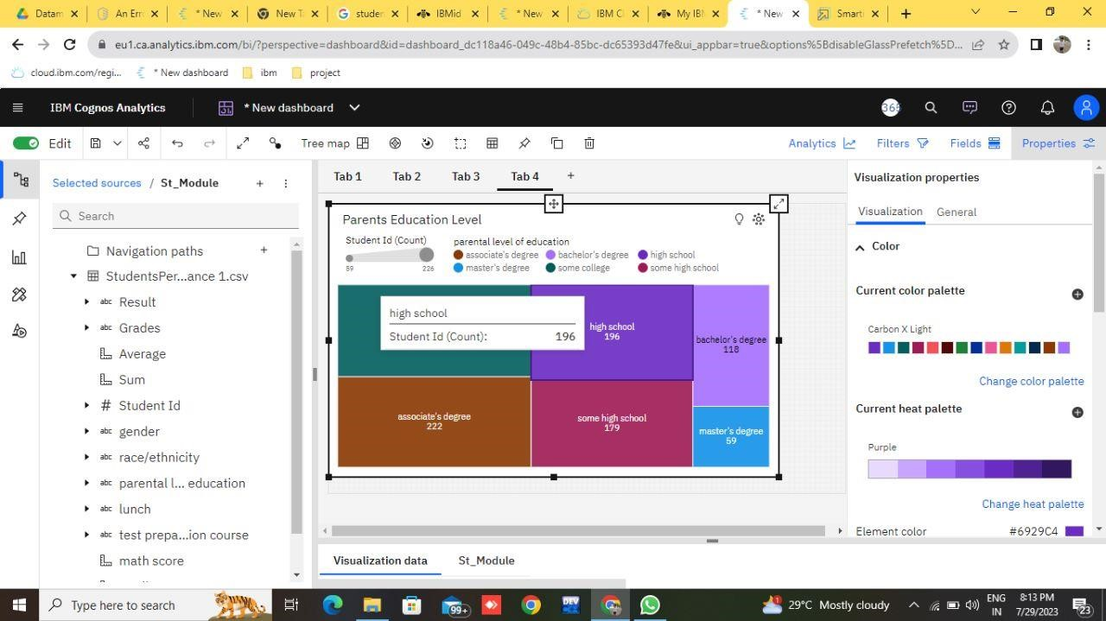

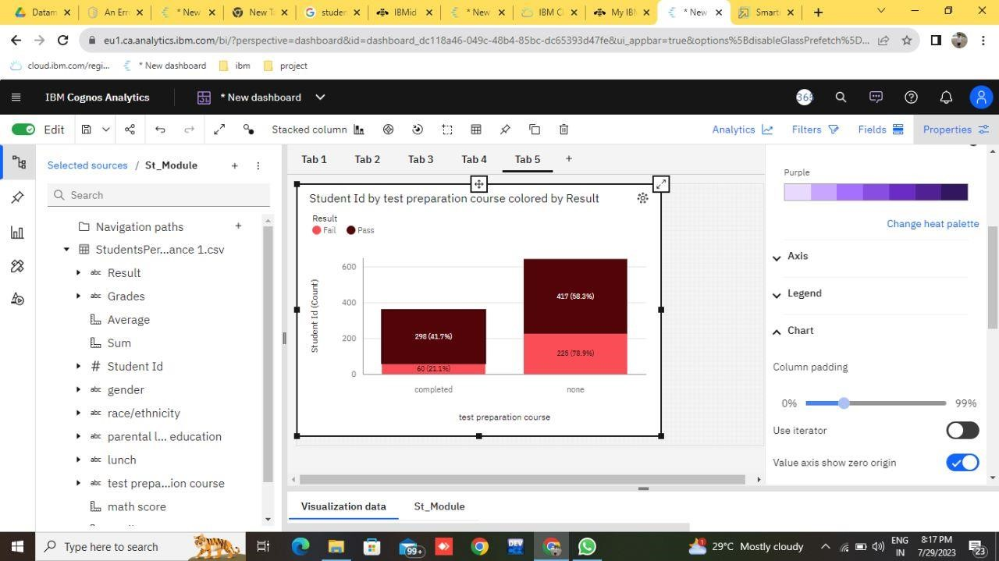

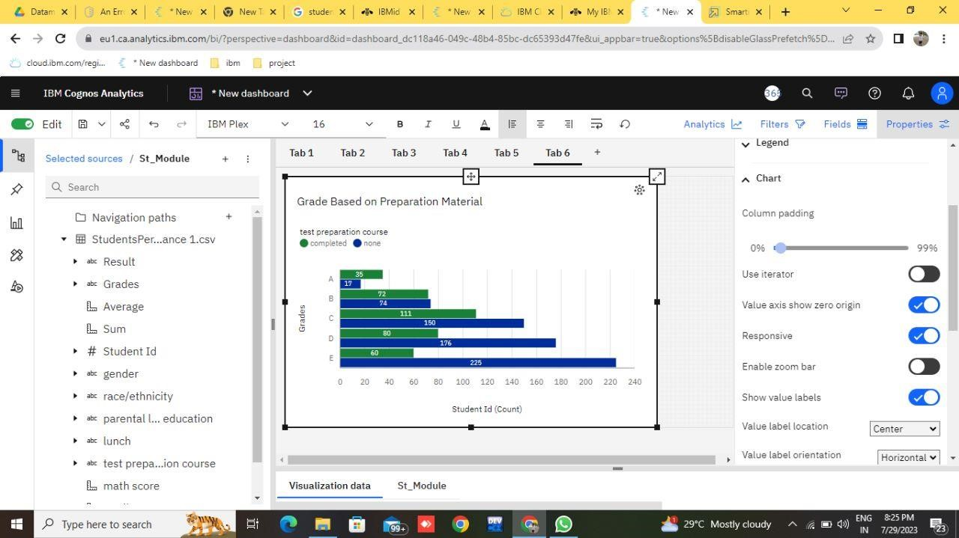

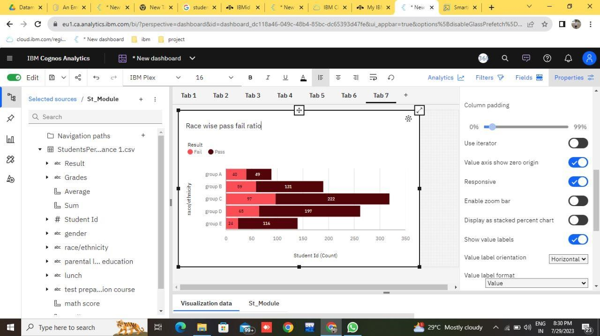

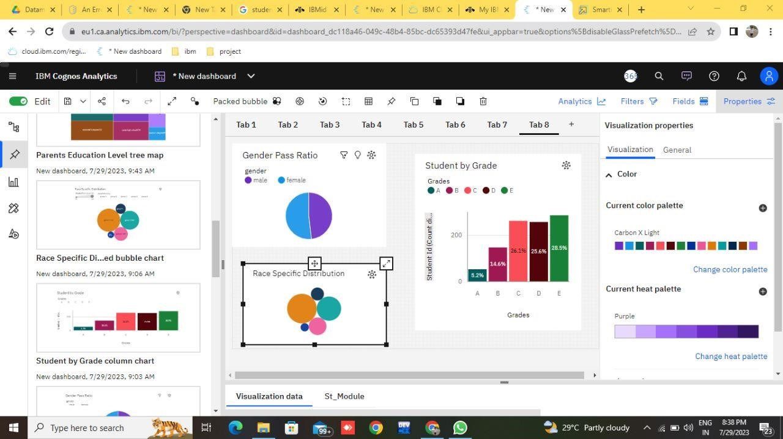

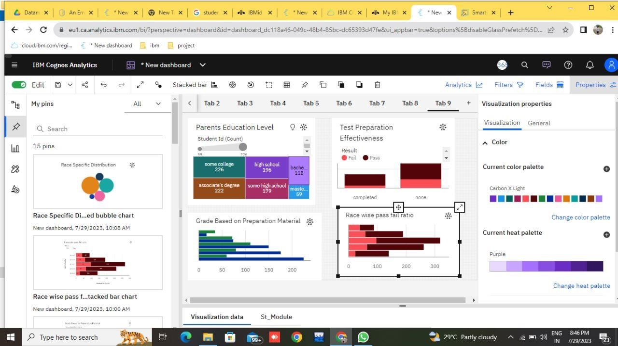

# CHAPTER 5 APPLICATIONS/ADVANTAGES

## ADVANTAGES

1. **Identifying Strengths and Weeknesses**
2. **Personalized Learning**
3. **Earlt Intervention**
4. **Urriculum Improvement**
5. **Teacher Professional Development**
6. **Monitoring Progress and Goal Setting**

## DIS ADVANTAGES

1. **Overemphasis on Testing**
2. **High-Stakes Pressure**
3. **Data Privacy Concerns**
4. **Teaching to the test**
5. **Inequity and Bias**
6. **Incomplete Picture of Student Learning**

### APPLICATIONS

Student performance analysis has numerous practical applications across various educational settings and levels. Some of the key applications include:

1. Personalized Learning
2. Early intervention and support
3. Cirriculim development and improvement
4. Tracking Academic Progress
5. Program Evaluation
6. Identification of Gifted and Talented Students

# CHAPTER 6 CONCLUSIONS & FUTURE SCOPE

## CONCLUSION

In conclusion, student performance analysis plays a pivotal role in modern education by providing valuable insights into the academic progress, strengths, and areas of improvement for individual students, groups, and educational institutions as a whole. Through a systematic examination of student performance data and various assessment methods, educators, administrators, policymakers, and researchers gain a deeper understanding of the factors influencing student outcomes.

By leveraging performance analysis, educators can implement personalized learning approaches, early intervention strategies, and targeted support systems, ensuring that each student receives the assistance they need to succeed. Moreover, the datadriven approach allows educational institutions to make informed decisions about curriculum development, instructional methodologies, resource allocation, and professional development for teachers

### FUTURE SCOPE

The integration of AI and ML algorithms into student performance analysis can enhance the accuracy of predictive models, identify subtle patterns, and provide personalized learning recommendations tailored to individual students.

With the availability of real-time data through digital learning platforms and educational technologies, student performance analysis can move beyond periodic assessments and provide continuous feedback to students and educators. This allows for timely interventions and immediate feedback loops for improvement.

Future performance analysis may encompass a broader range of assessment methods, including multimodal assessments that capture students' abilities and progress through various means, such as written, visual, auditory, and interactive assessments.

#### Inference

IBM Database extracted from smart internz.

Google.



